**EQUILIBRIUM PRICING MODELS**

**1. CAPM**

Purpose Price risk return at equilibrium

Additional Assumption to CML:

M ≈ Tangent Portfolio ≈ Universal market Portfolio

* Consists of all risky assets in the Universe!!
* Composition: each asset is held in proportion to the market value (MV) of all securities.

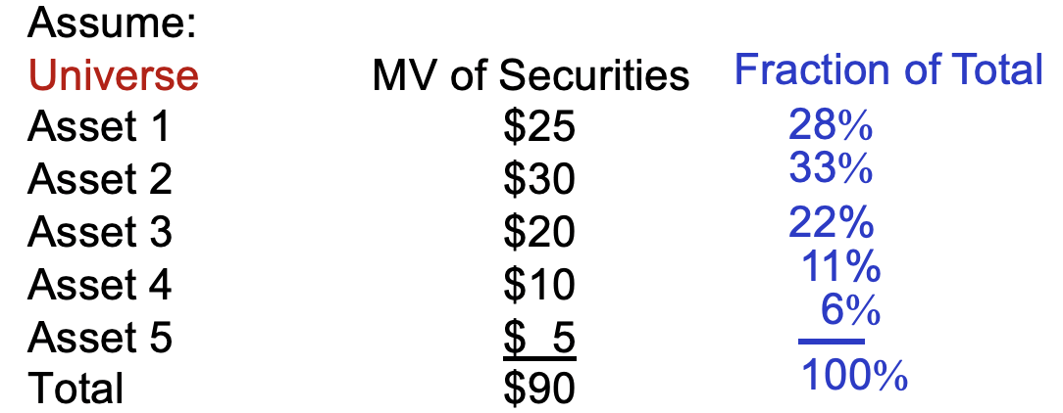

* M is well diversified → Relevant risk? Market Risk

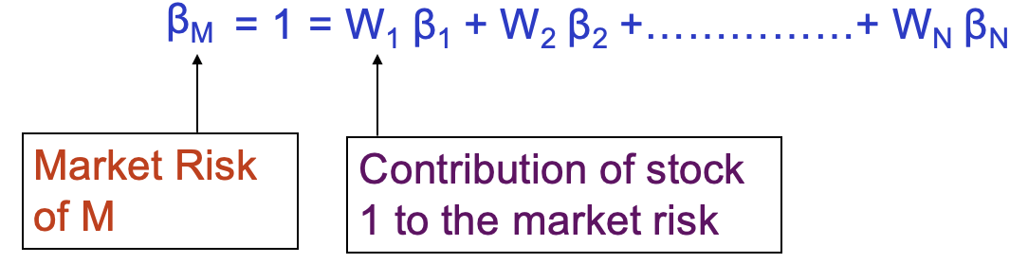

Note: ***Beta*** is an appropriate measure of the stock's risk when it is part of a well-diversified portfolio.

Total risk is called *sigma.*

Our measure of market risk is called *beta*, and is defined as the covariance between the return of a stock and the return on the market portfolio, divided by the variance of the return on the market portfolio

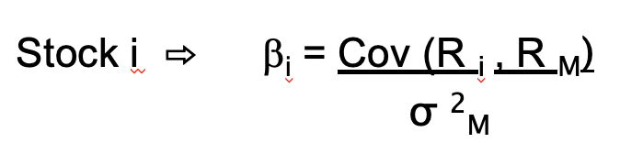

* This is an ex-ante estimate of the “non diversifiable risk” relative to the Market Portfolio
* It is based on a theory in which there is a single investment period

Theoretically, beta could be negative; but it is practically impossible.

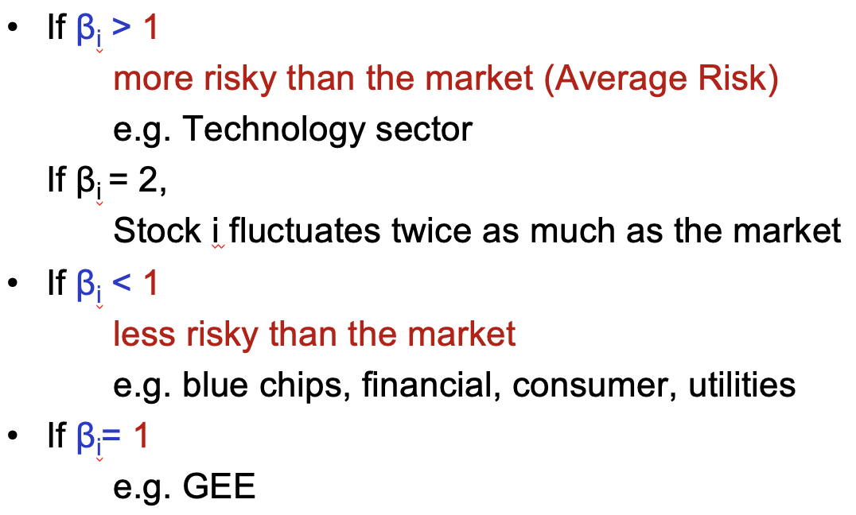

[Equilibrium CAPM]

The equilibrium expected return on any security (or portfolio of securities) is equal to a risk-free return plus a risk premium.

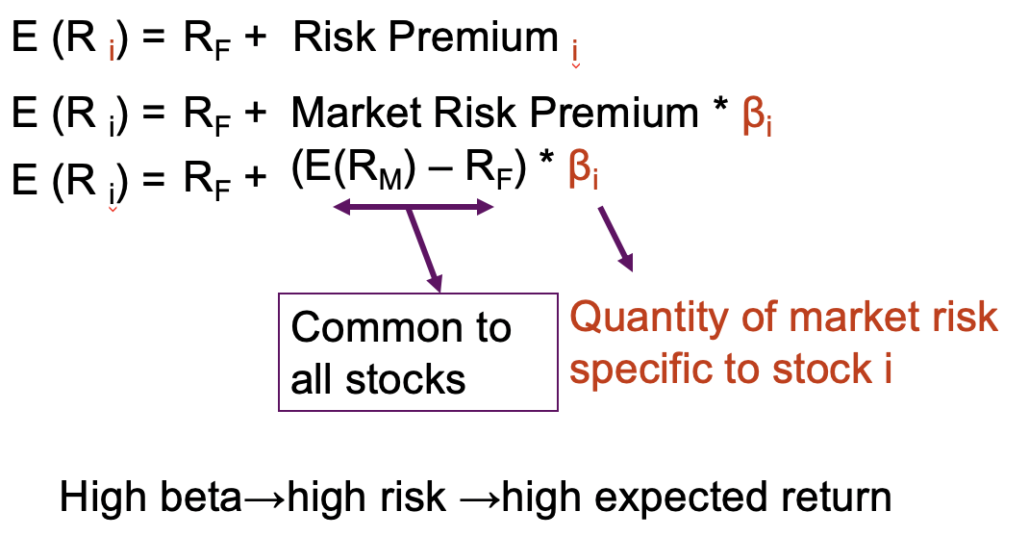

<Example 1>

The expected market return is 12%. The risk free rate is 6%.

What is the expected return of a stock with a beta of 0.8?

E(R)=6%+0.8(12%-6%)=10.8%

What is the expected return of a stock with a beta of 1?

E(R)=6%+(12%-6%)=12%

What is the expected return of a stock with a beta of 0?

E(R)=6%+0(12%-6%)=6%

Positive linear relation between expected return and beta

[Security Market line]

graphical representation of CAPM

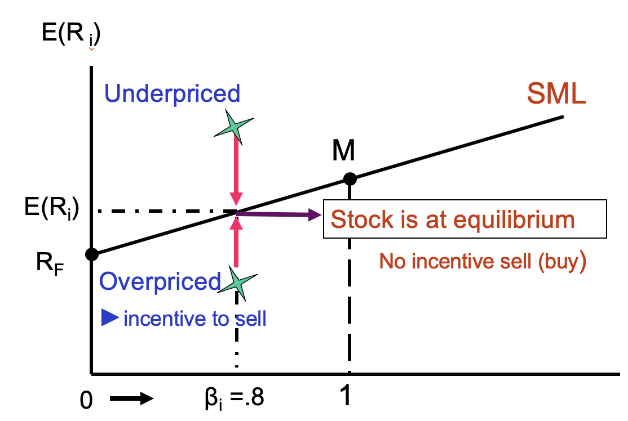

**Required**

**return**

difference between CML and SML

CML: risk is based on sigma

SML: risk is based on beta

**Mispricing**

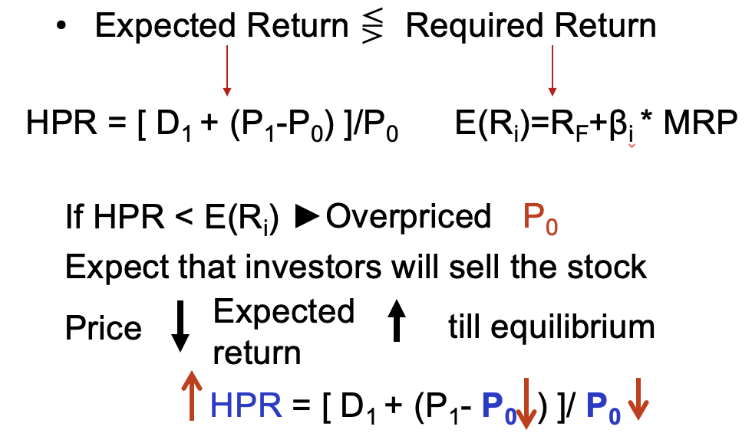

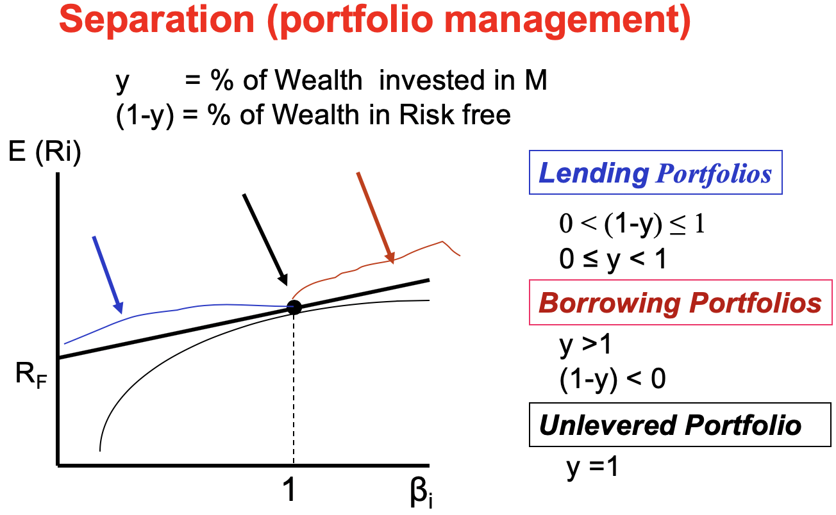

Along the SML

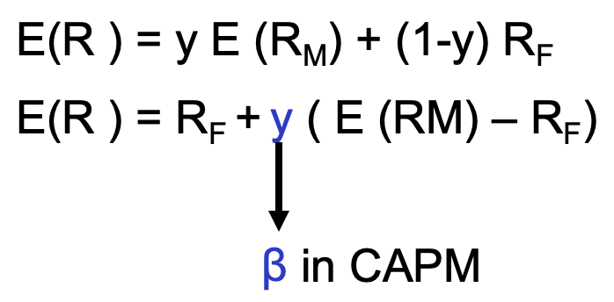

New interpretation of beta:

Percentage of your initial wealth invested in your market portfolio

Application of CAPM:

* arbitrage
* price stock

<Example 2>

βi= .8, E(RM) = .12, RF= .07, P1 = $21.5, P0 = $20

1. Position of the stock?

Expected return HPR= $\frac{D1+P1-P0}{P0}$ (21.5-20)/20 = 7.5%

Required return CAPM 0.07+0.8(0.12-0.07) = 11%

🡪 overpriced

2. Equilibrium price? Prediction?

P0 =

= 19.37

Price = PV of Expected CF

21.5

3. Any **arbitrage** oprtunity? Look for mispricing?

NO risk, NO investment

-Same risk, but NOT same return (price)

-Sell unattractive ones and buy attractive ones

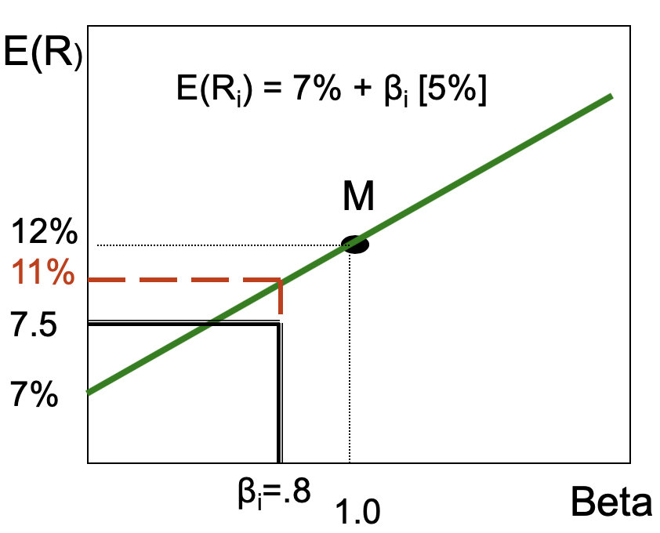

Make money from nothing

1. Short sell Sk

2. Buy Portfolio of M and RF

with y = 0.8 & (1-y)= 0.2

or 0.11 = 0.12y +0.07(1-y)

spread = 0.11-0.075=3.5%

Note: arbitrage is different from speculation

Speculator will wait until price goes up, but arbitrager doesn’t need to wait

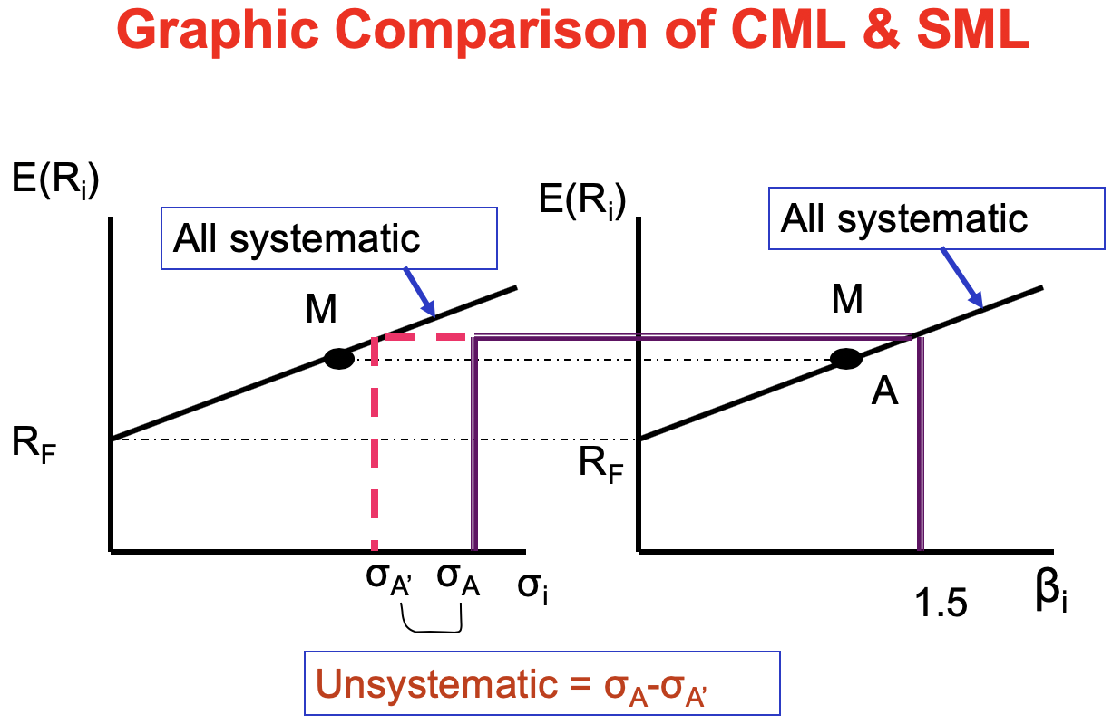

In practice, use S&P(New York) and TSX(Toronto) for M

CML is a better model since it also reflects unsystematic risk. But CAPM is more often used in practice.

<Example 3>

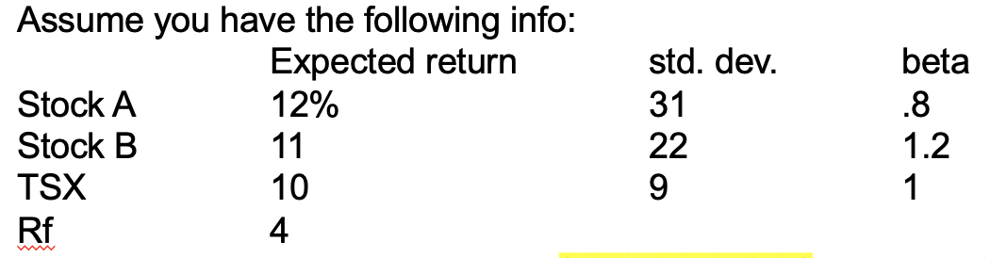

a. Which stock would you add to a (well-diversified) index portfolio of the stock market? **CAPM**

RrquiredA = 4+0.8(12-10)=5.6% 🡪better

RequiredB = 4+1.2(11-10)=5.2%

b. Which stock would you add to a single-stock portfolio? **CML**

Sharpe ratioA = (12-4)/31=0.258

Sharpe ratioB = (11-4)/22=0.318 🡪better

[Testing CAPM]

* Positive relationship between risk and return

►Theory is correct

* But the Model is not consistent with reality

►There are many missing factors such as dividend yield, size, earnings…

But CAPM is very popular in real life because of simplicity.

**2. Index model**

**Single Index Model (SIM)** for one stock

unsystematic

ri = αi + βi ri  + ei

systematic(GNP or interest…)

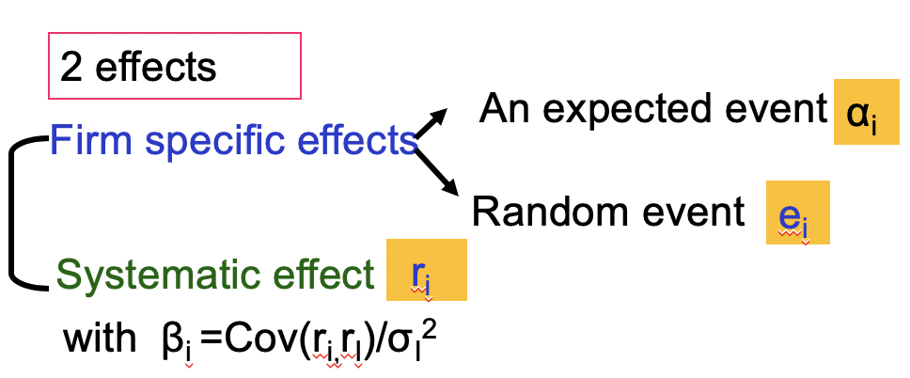

e.g. div, CapEx…

[Properties]

Cov (ri, ei)=0

e.g. heart attack…

E(ei )=0

Cov(ei, ej)=0

**Systematic & Firm specific Risk of an Asset according to the SIM**

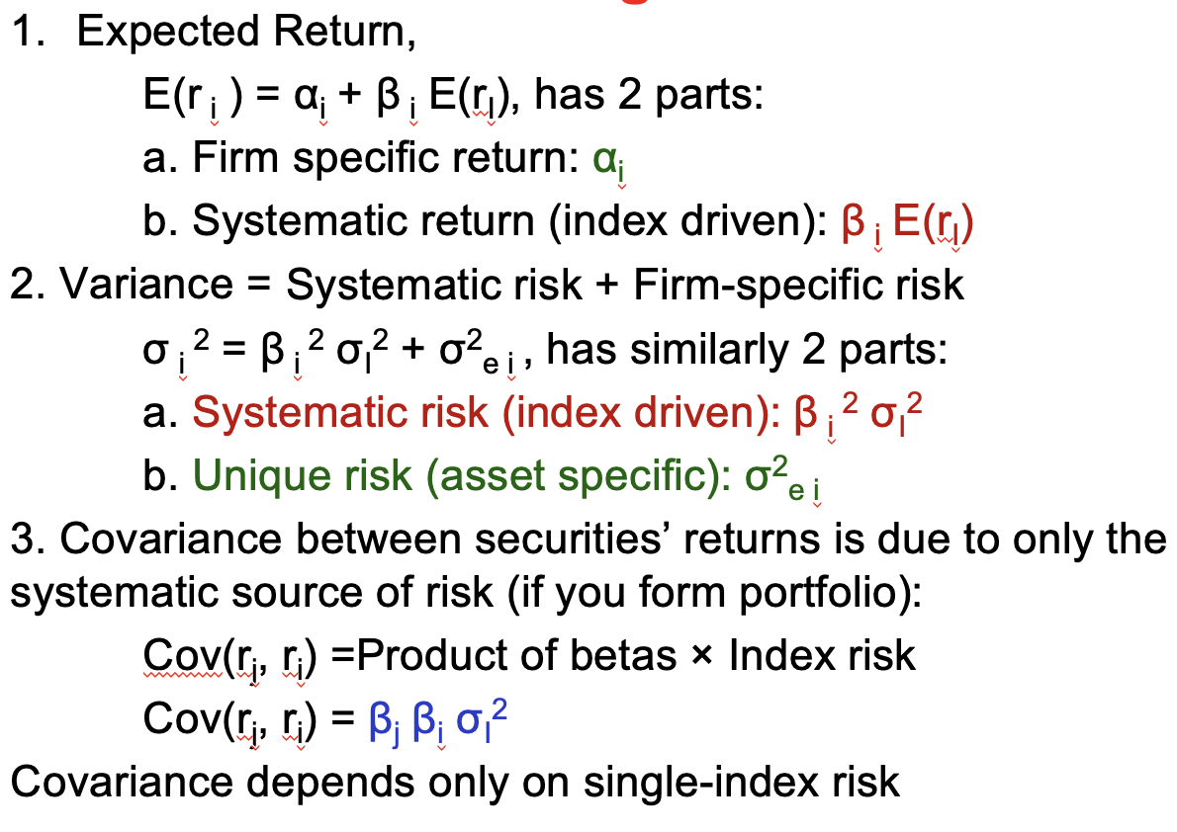

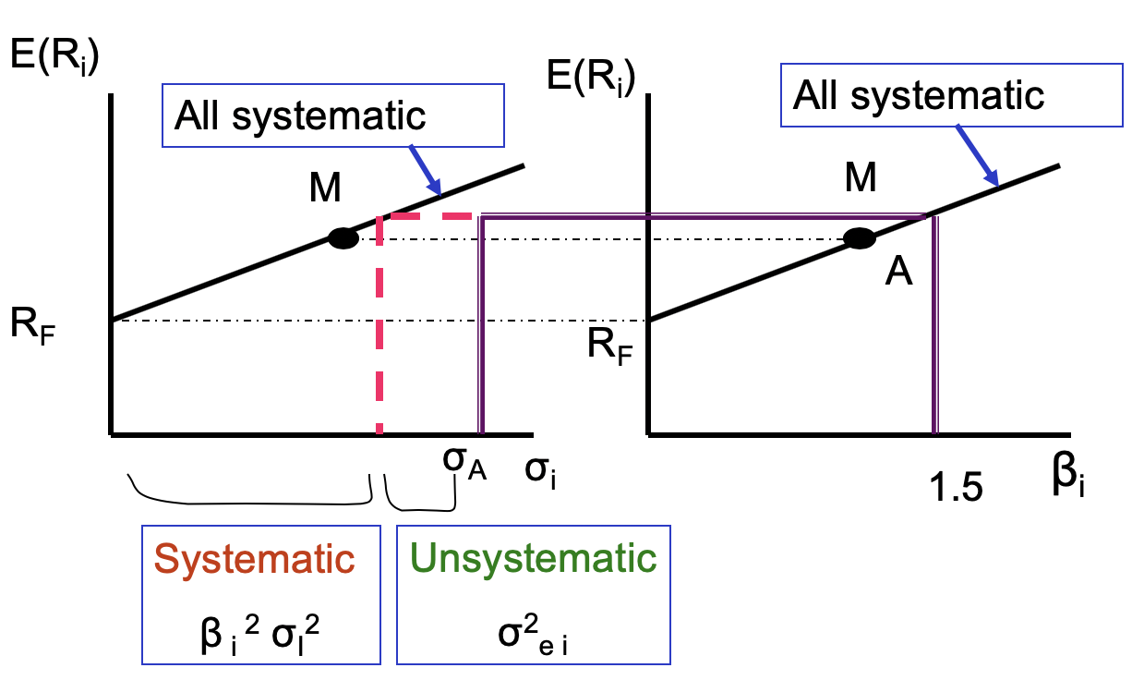

**[Estimation of beta (CAPM)]**

if Index= Stock Market ►CAPM(ex-post)

Use a regression equation of SIM

r it = **α**+ **β** (rMt) + e it

**Single Index Model** or **Sharpe Model** or **Market Model**

**Single Index Model** or **Sharpe Model** or **Market Model**

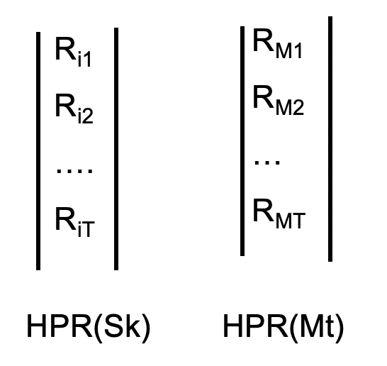

<Excel>

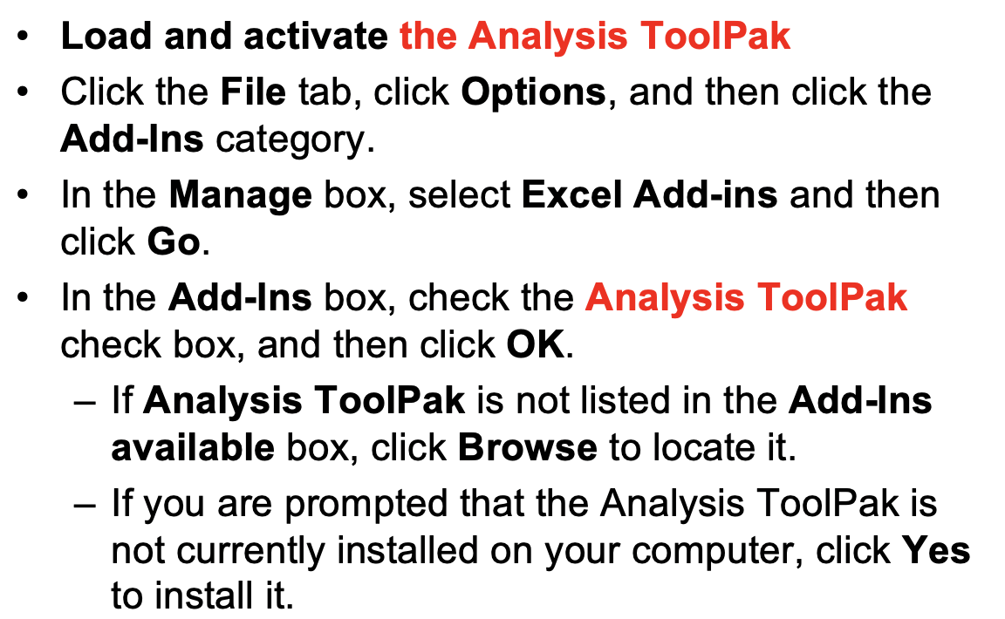

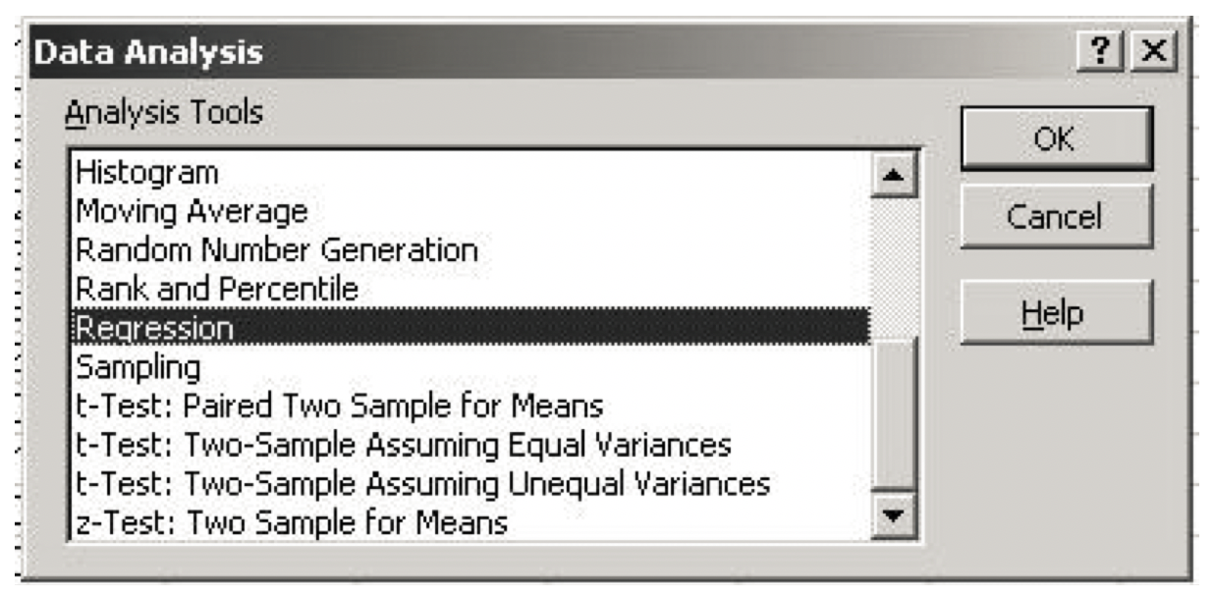

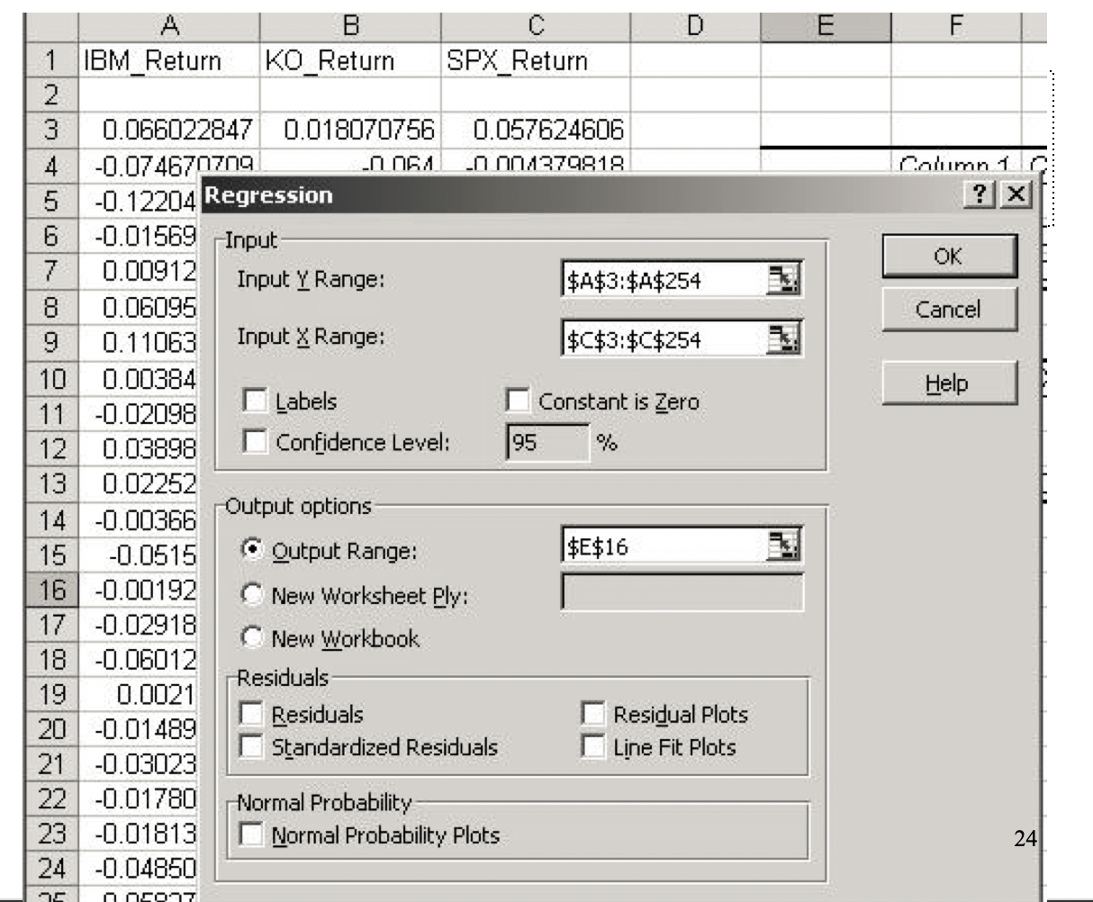

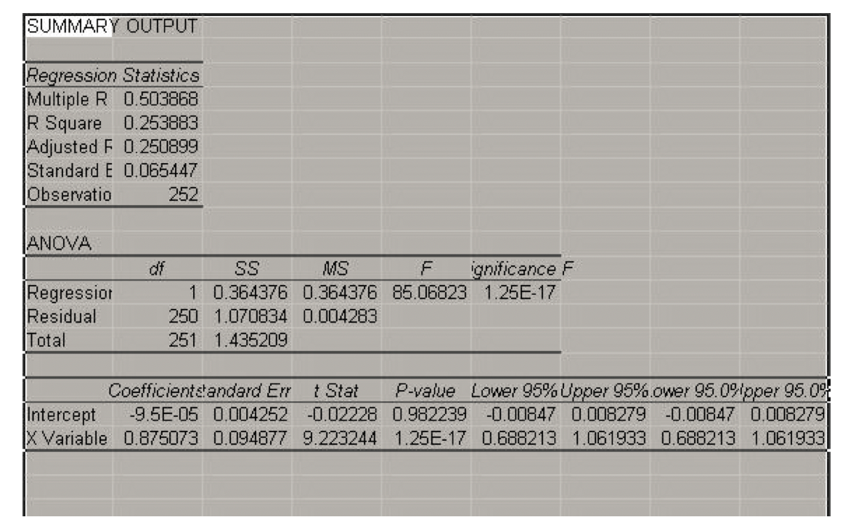

**beta**

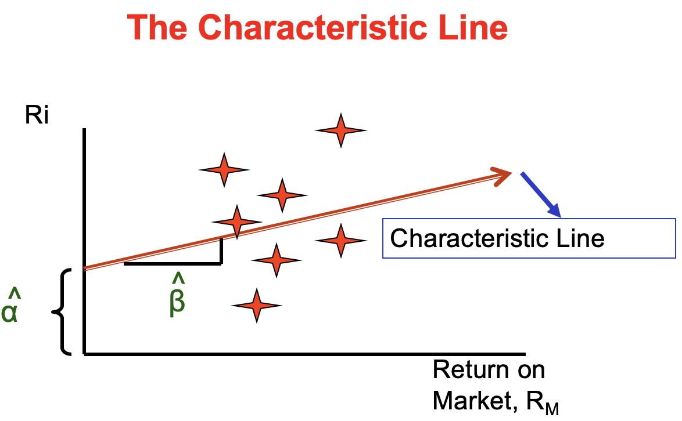

slope of the regression line: beta

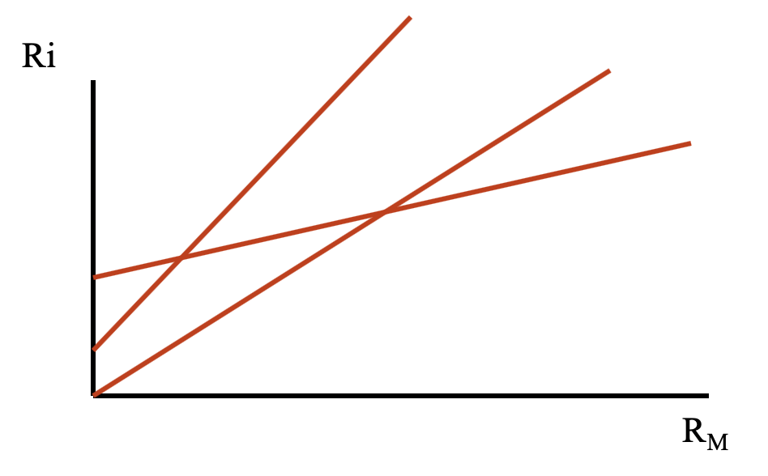

defensive beta<1

aggressive beta>1

neutral beta=1

**[Adjusted Beta]**

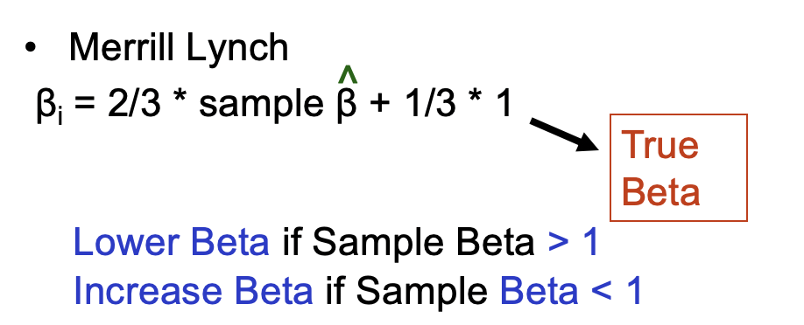

Reason : Beta of the stock should converge toward “1” overtime

As firms grows, it tends to diversify and starts to look like the market

**Predicting Return of MSFT**

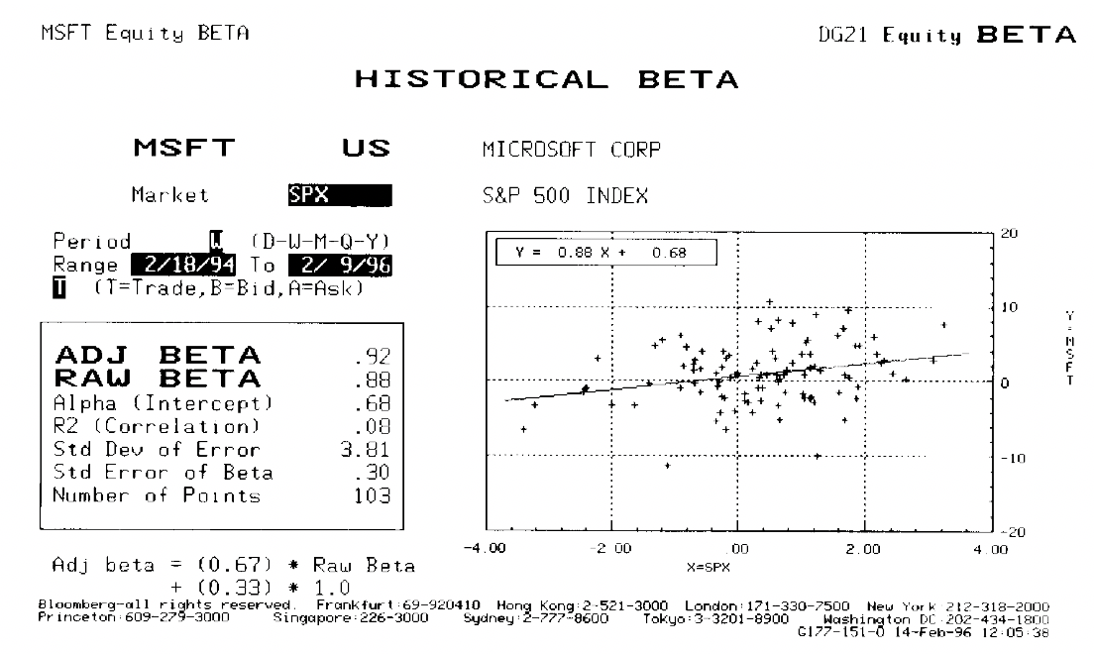

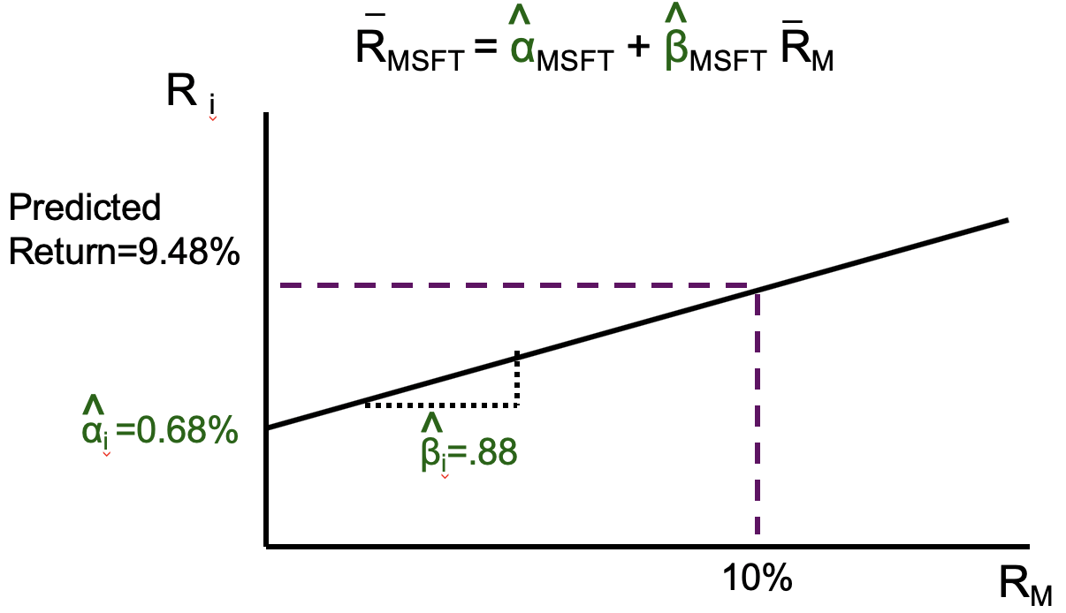

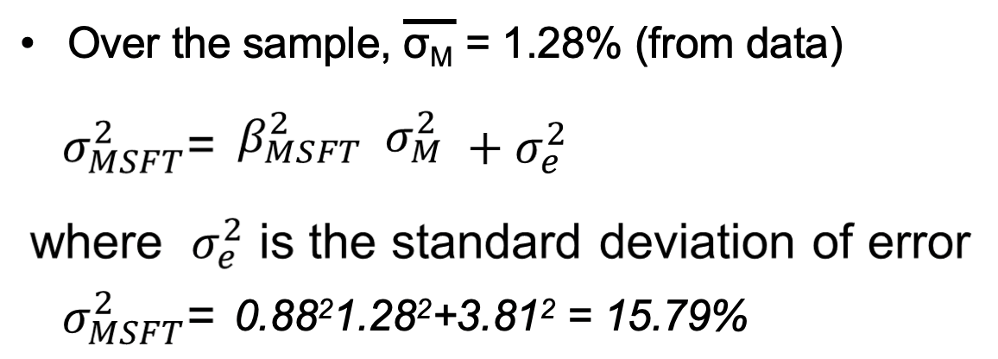

R2 = = = 0.08

To what degree systematic risk influence return volatility.

🡪 Unsystematic risk is more important to MSFT

<Example 4>

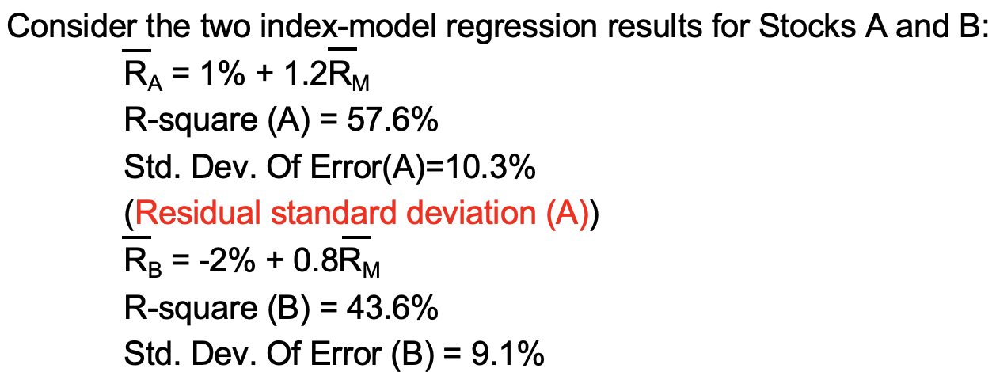

a. Which stock has more firm-specific risk?

Thus, stock A has more firm-specific risk, 10.3>9.1

b. Which stock has greater market risk?

Stock A has a larger beta coefficient, 1.2>0.8

c. For which stock does the market explain a greater fraction of return variability?

Stock A’s R-square is larger than R’s, 57.6%>43.6%

**[Portfolio]**

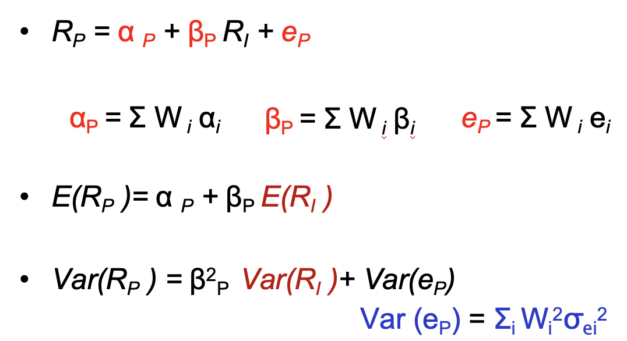

The Index Model Helps us to Derive the Optimal Portfolio for Asset Allocation (the Tangent Portfolio M) by **Reducing the Necessary Inputs** to the Markowitz Portfolio Selection Procedure

[Multi-index Model]

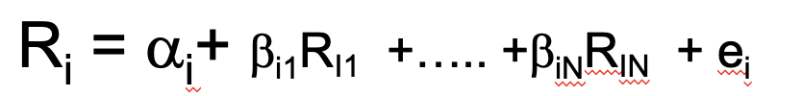 NOT testable

**3. ARBITRAGE PRICING THEORY**

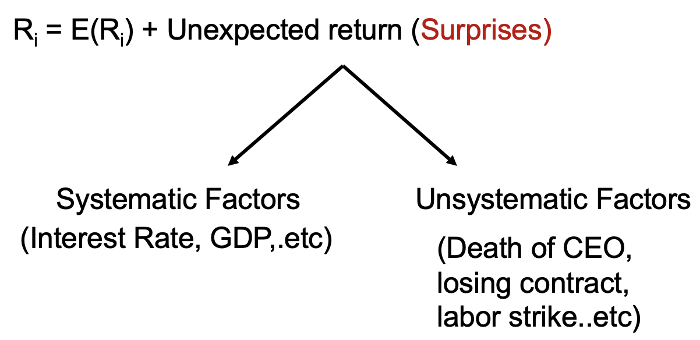

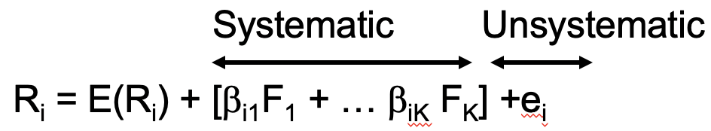

where **βi1** is called **Factor loading** which measures the sensitivity of F1 to Ri

and **F1** is called **Factor price** which is the source of macro-surprise from factor 1

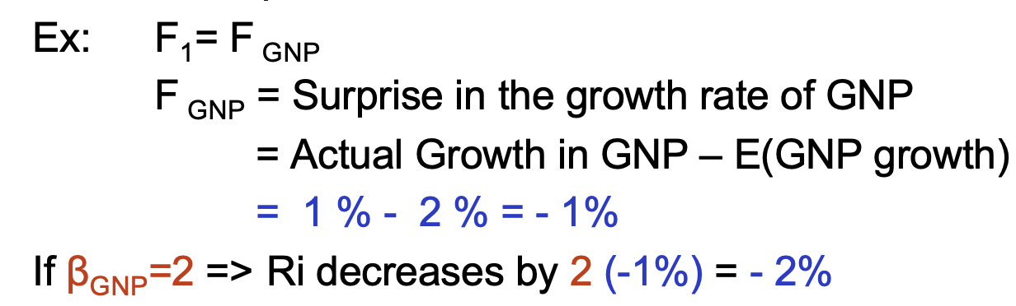

**Risk-return of one factor Model --- One Stock**

Expected value of surprise is 0: E(ei)=0

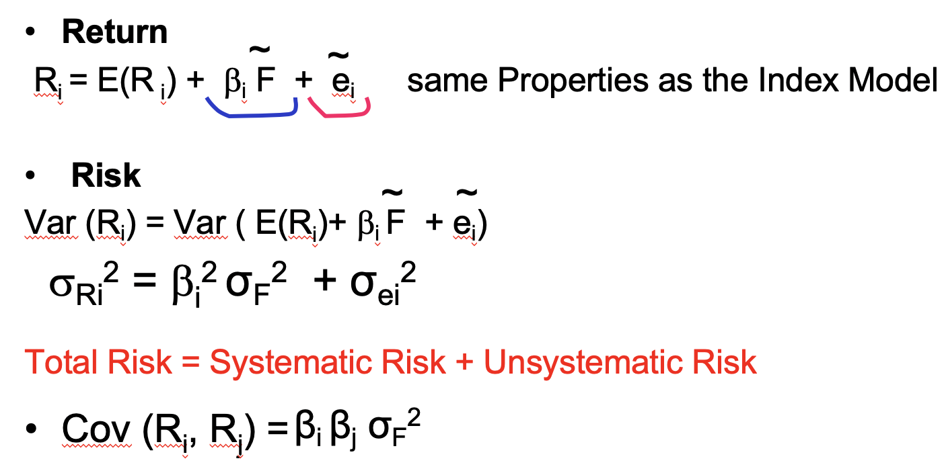

**Risk-return of One Factor Model --- Portfolio of stocks**

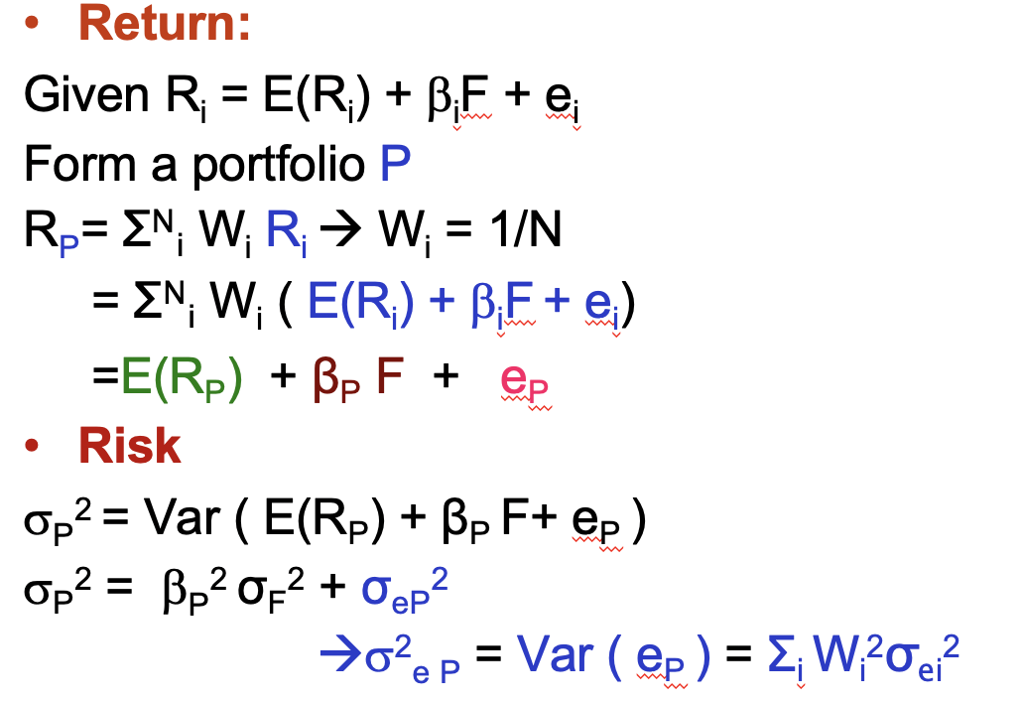

If P is well diversified,

R P =   E(RP) + βP F

σ2 P= βP2 σF2

**Risk-return of Multi-factor Model --- Portfolio of stocks**

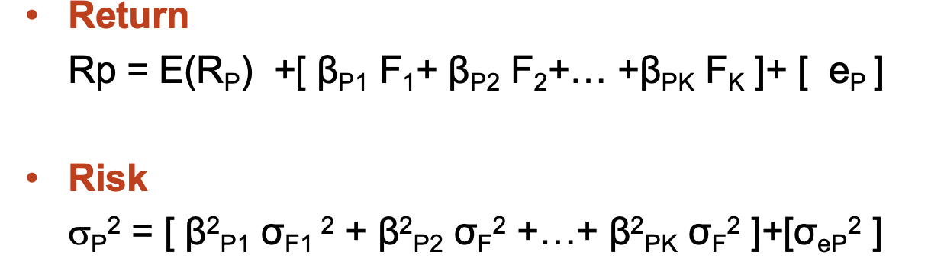

If P is well diversified,

Rp = E(RP) +[ βP1 F1+ βP2 F2+… +βPK FK ]

σP2 = [ β2P1 σF1 2 + β2P2 σF2 +…+ β2PK σF2 ]

< Example 5 >

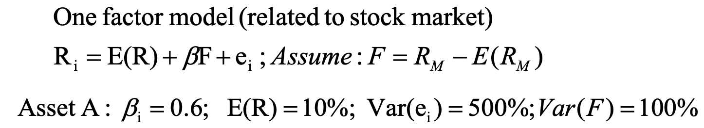

i) If we have one asset in the market

Var(RA) = 0.62*100%+500% = 536%

ii) If we have an infinite # of asset A i.e well diversified portfolio

Var(Rp) = 0.62*100% = 36%

**Equilibrium APT --- Expected Return APT**

***The Law of One Price*** *: This is the fundamental economic principle underlying APT*

* Two identical goods must sell at the same price

or there would be arbitrage profits available

* Strict Arbitrage consists of:

No Investment

No Risk

Positive Return

< Example 6>

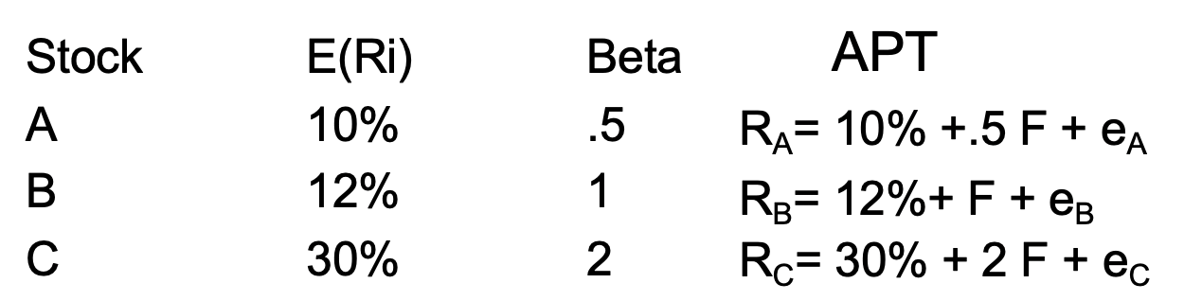

Arbitrage Profit ?

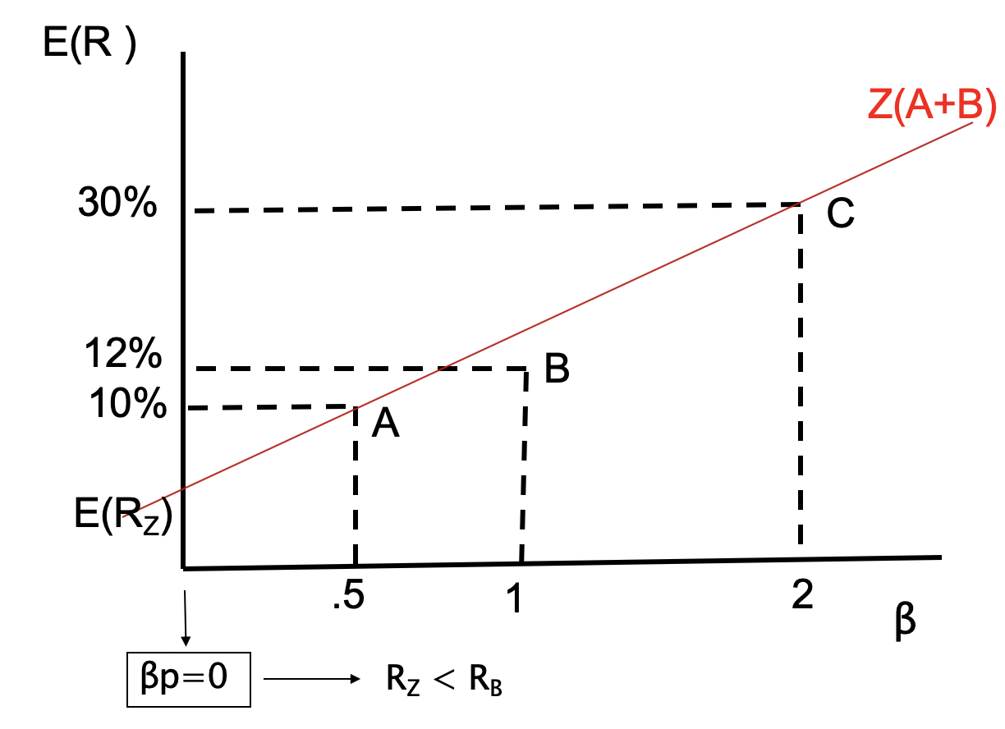

βz=WAβA+WCβC=0

🡪 WA=1.33 WC=-0.33

E(RZ)=1.33*10%-1/3*30%=3.3% VS E(RB)=12%

An arbitrage opportunity exists by buying $1M stock B and selling an equal amount of portfolio Z. If you do so, your profit will be $RB - $RZ = (12%)1M-(3.3%)1M = $87000

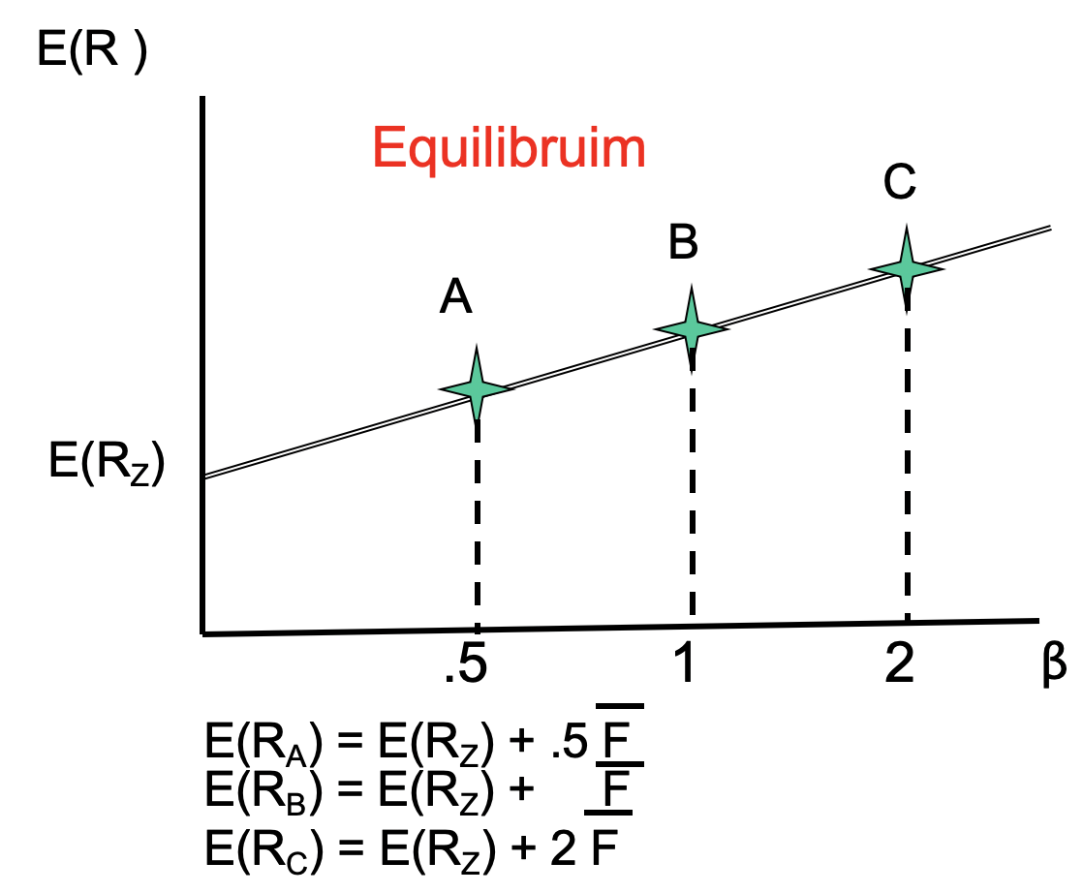

**[Differences: CAPM vs APT]**

